Counting Identifiers in a C Program Using LEX
Aim :
To write a LEX program to read a C source file and count the number of identifiers present in the program, ignoring keywords, constants, comments, spaces, and special symbols.

Pseudocode :
BEGIN
Open source.c
If file cannot be opened
Print error message
STOP
End if

Set identifier count = 0
Read source file using yylex()

For each word
If word is not a keyword
Count it as an identifier
End if
End for

Display identifier count
Close source file
END

Code :

%{
#include <stdio.h>
#include <string.h>
int count = 0;
int keyword(char *s)
{
char *k[] = {
"int", "char", "float", "double", "if", "else",
"for", "while", "do", "return", "void", "break",
"continue", "switch", "case", "default", "long",
"short", "const", "static", "struct", "sizeof"
};
int i;
for (i = 0; i < 22; i++)
if (strcmp(s, k[i]) == 0)
return 1;
return 0;
}
%}
%x COMMENT
%%
"/*" { BEGIN(COMMENT); }
<COMMENT>"*/" { BEGIN(INITIAL); }
<COMMENT>\n ;
<COMMENT>. ;
"//".* ;
\"([^\\\n]|\\.)*\" ;
\'([^\\\n]|\\.)*\' ;
[A-Za-z_][A-Za-z0-9_]* {
if (!keyword(yytext))
count++;
}
[0-9]+ ;
[ \t\n]+ ;
. ;
%%
int yywrap(void)
{
return 1;
}
int main(void)
{
FILE *fp = fopen("source.c", "r");
if (fp == NULL)
{
printf("Error opening file\n");
return 1;
}
yyin = fp;
yylex();
printf("Number of identifiers: %d\n", count);
fclose(fp);
return 0;
}

Output :
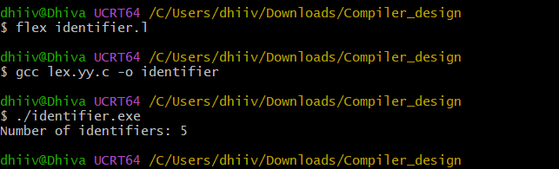

Result :

Thus, the LEX program successfully counts the identifiers present in the given C source file, excluding the keywords, constants, comments, spaces, and special symbols.

